Issue in Optional Coverage tab when Industry is Community Bank

Steps-

Create a quote with Industry Class as ‘Community Bank’

Recall the quote in UWP

Proceed to COB tab, select ‘Yes’ for Security question 3

Verify the optional coverage tab

select ‘No’ for Security question 3

Verify the optional coverage tab

Actual Result-

The 'Include Funds Transfer Coverage?' and 'Included Fraudulent Instruction Coverage?' fields are displaying No Change in Coverage when Security Question 3 is selected as ‘Yes’; when changed to ‘No’ the values in optional coverage tab displays Delete Coverage and disabled.

Expected Result-

The 'Include Funds Transfer Coverage?' and 'Included Fraudulent Instruction Coverage?' fields will be disabled and default to 'Delete Coverage' regardless of the Security Question#3 value.

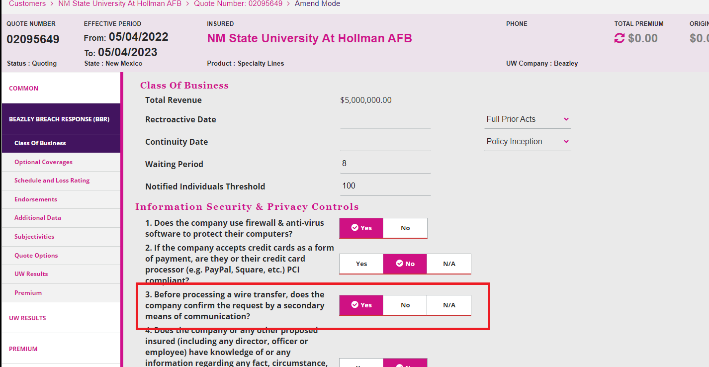

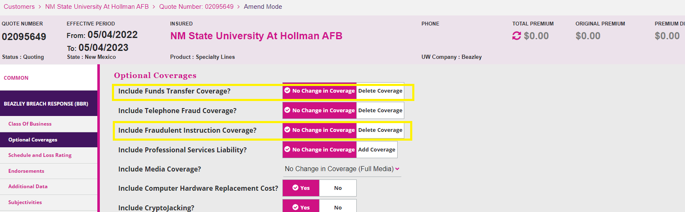

Test Results:

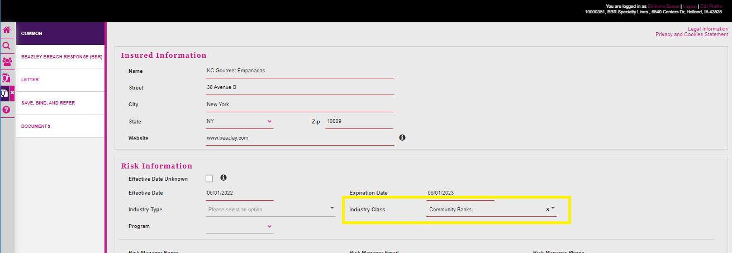

If question # 3 = Yes

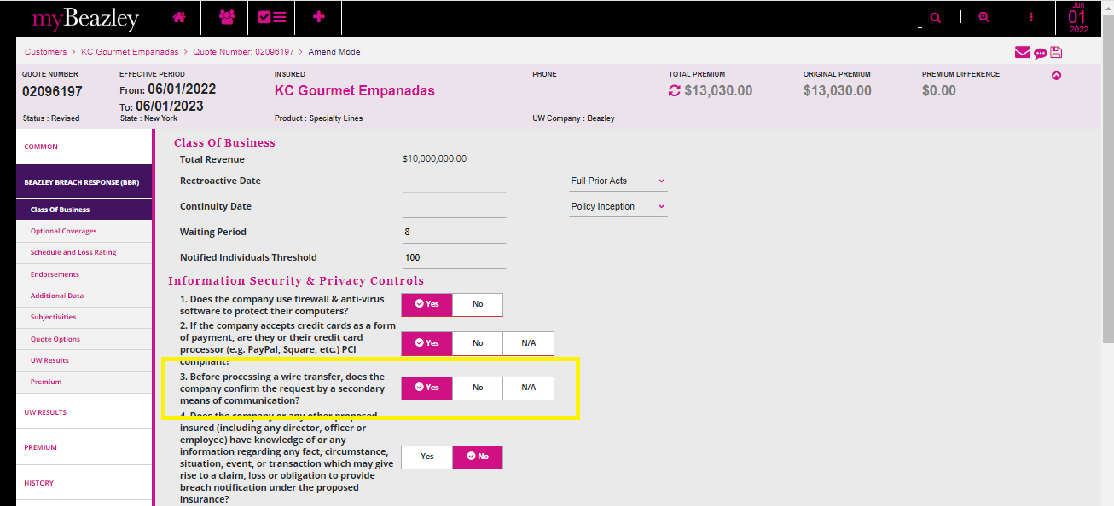

If Question # 3 = NO

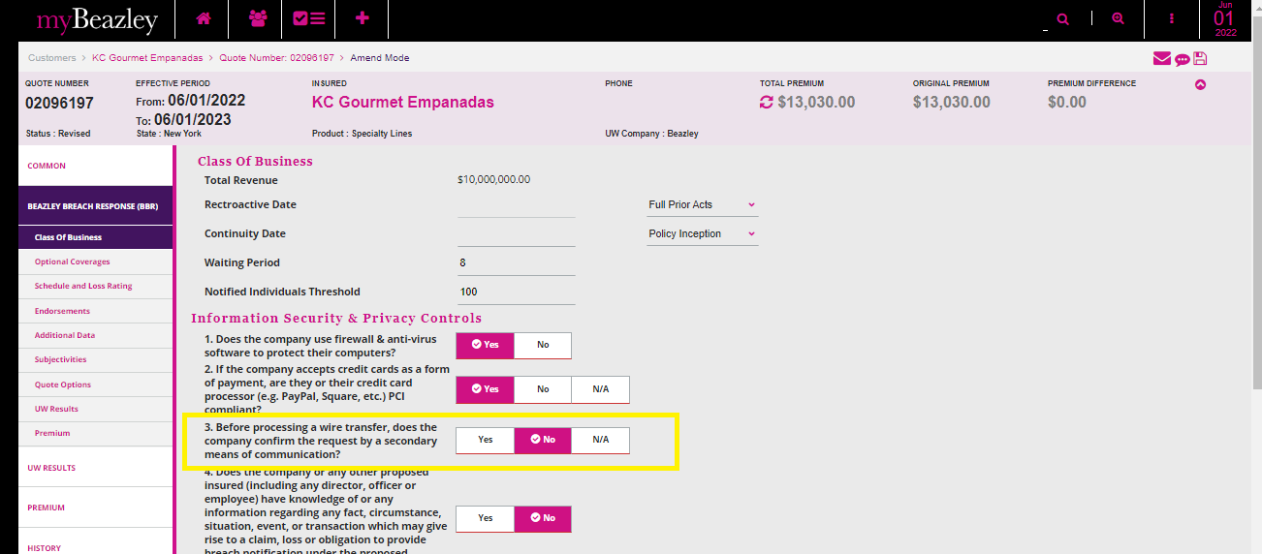

In both cases the 'Include Funds Transfer Coverage?' and and 'Included Fraudulent Instruction Coverage?' fields were the same ('Delete Coverage') regardless of the Security Question#3 value.

In conclusion, the actual result is equal to the expected result.

Using “Bank Holding Companies”



